SOCIAL MEDIA

- The SFAF includes performance measures which are applicable to Canadian Sport Centres (CSC), Canadian Sport Institutes (CSI), National Sport Organizations (NSO) and Multisport Service Organizations (MSO).

- Two performance measures are related to official languages:
  - The organization provides programs and services and related communications in both official languages, simultaneously where indicated.
  - The organization releases communications to the public simultaneously in both official languages.

The organization releases communications to the public simultaneously in both official languages.
    - Web site
    - Social media
    - Promotional material and activities

***********************************

Level 1 – Initiating
- The organization develops a strategy for its communications via social media.

Some elements to consider
- Bilingual or separate equivalent unilingual versions available in each official language.
- When two separate unilingual versions are produced, steps should be taken to ensure that users of both versions have an equally rewarding experience.
- When two separate unilingual versions are produced, it should be indicated that a version in the other official language is also available.
- When a bilingual version is produced, the title of the page (name of the organization) must be bilingual when the account is created.

Level 2 – Emerging
- The organization has a strategy implemented for its communications via social media.

Level 3 – Developing
- The static content has equivalent content and equal language quality in both official languages.
- Static content – Examples (non-exhaustive list)
Organization profile, conditions of use, contact information, etc.
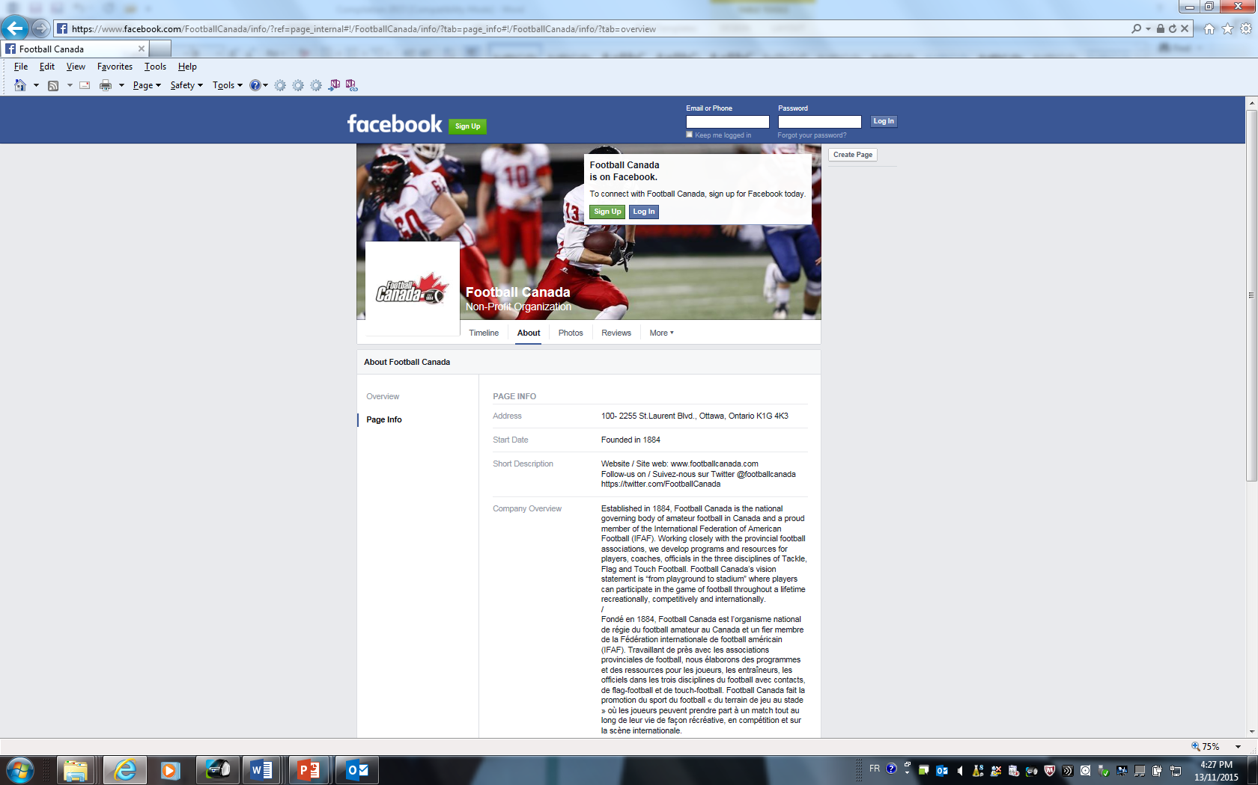
https://www.facebook.com/FootballCanada/info/?ref=page_internal#!/FootballCanada/info/?tab=page_info#!/FootballCanada/info/?tab=overview

Level 4 – Implementing
- The communications from the organization have equivalent content and equal language quality in both official languages.

Informative communications from the organization
- When an organization posts information of general interest, it must be available in both official languages. Examples: announcements of results, upcoming events, job offers, etc.

Questions or comments from the public
- The organization responds to questions or comments from the public in the official language they were received.

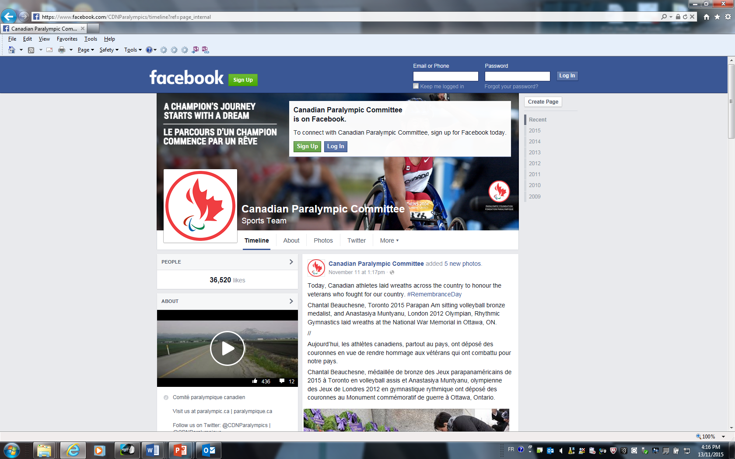
https://www.facebook.com/CDNParalympics/timeline?ref=page_internal

Level 5 – Robust
- External content posted by the organization is available for all users regardless of the language used by the external souce.

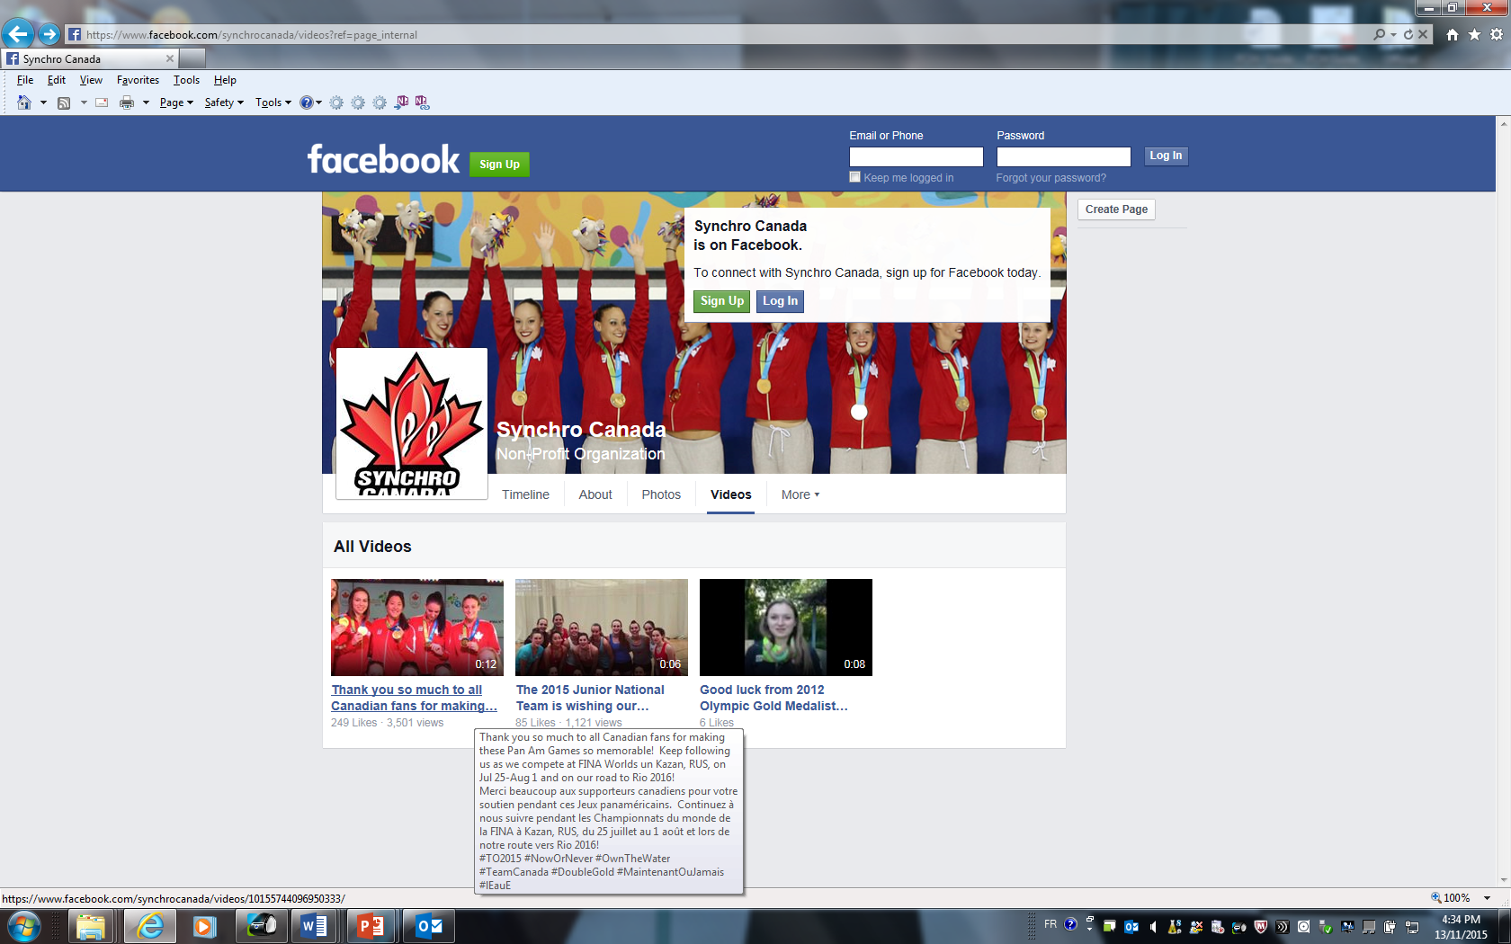
https://www.facebook.com/synchrocanada/videos?ref=page_internal

